Assignment 2 Report

**Part 1**

* Setting: In a magical Forrest.
* Goal: to reach a castle.
* Scoring: The player will score depending on how close they are to the castle.

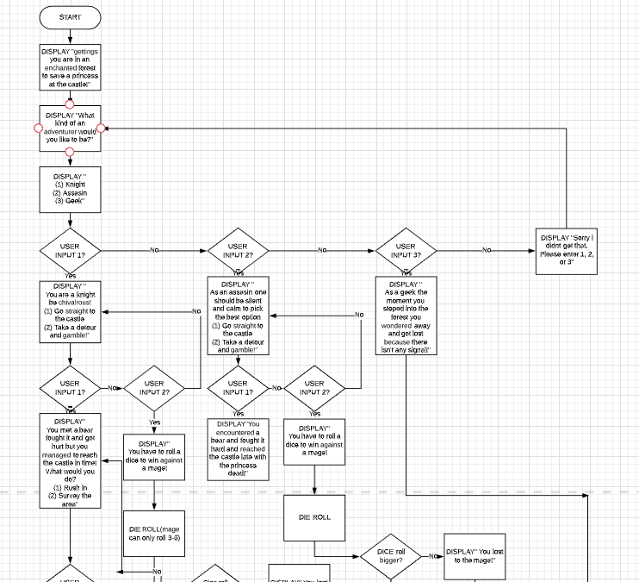

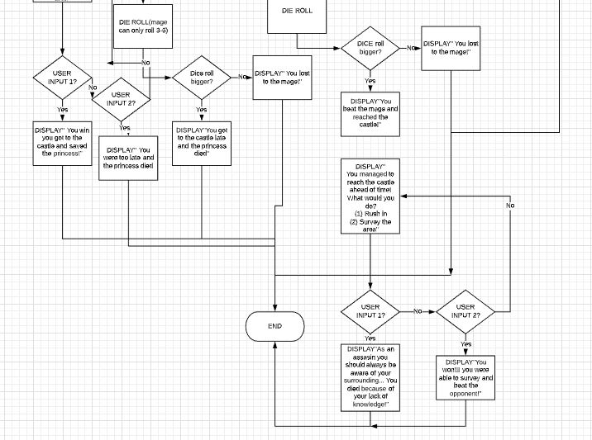

|  |  |  |
| --- | --- | --- |
| Test Case setting | Player input | Expected result |
| DISPLAY “  Greetings you’re in an enchanted forest to save a princess at the castle!  What kind of an adventurer would you like to be? (1) Knight  (2) Assassin  (3) geek  “ | 1 | DISPLAY “  You’re a knight, be chivalrous!  (1) go straight to the castle  (2) take a detour and gamble” |
| DISPLAY “  Greetings you’re in an enchanted forest to save a princess at the castle!  What kind of an adventurer would you like to be? (1) Knight  (2) Assassin  (3) geek  “ | 2 | You are an assassin! BE CUNNING!  (1) Take the road that leads straight to the castle!  (2) Find a different path through the forest! |
| DISPLAY “  Greetings you’re in an enchanted forest to save a princess at the castle!  What kind of an adventurer would you like to be? (1) Knight  (2) Assassin  (3) geek  “ | 0 | I dont get you...  Your score is 1  Atleast you tried!  Do you want to play again (Enter 1 for yes)?” |
| DISPLAY “  Greetings you’re in an enchanted forest to save a princess at the castle!  What kind of an adventurer would you like to be? (1) Knight  (2) Assassin  (3) geek  “ | 1.0 | You are a knight! BE CHIVALROUS!  (1) Take the road that leads straight to the castle!  (2) Find a different path through the forest! |
| Do you want to play again (Enter 1 for yes)? | 1 | You are in an enchanted forest to save a princess in a castle!  What kind of adventurer would you like to be?  (1) Knight  (2) Assassin  (3) Geek  Your choice: |
| Do you want to play again (Enter 1 for yes)? | 0 | flip1 ~/CS161/Assignments/Assignment2 578$ |
| You are a knight! BE CHIVALROUS!  (1) Take the road that leads straight to the castle!  (2) Find a different path through the forest! | 2 | You took the forest path and marched through swamps...  When you got to the castle..  You heard a loud bang, and when you looked for the room you see that a troll is eating her from the head down...  ONLY IF YOU WERE A TINY BIT FASTER!  Your score is 10  Do you want to play again (Enter 1 for yes) ? |
| You are a knight! BE CHIVALROUS!  (1) Take the road that leads straight to the castle!  (2) Find a different path through the forest! | 3 | Wrong choice buddy...  Your score is 10  Do you want to play again (Enter 1 for yes)? |

**Part 2**

N/A

**Part 3**

In the other attached file

**Part 4**

(A) (2 pts) Were 8 test cases enough to cover all possible user inputs for your game? If not, why not?

It is not enough, because there are 23 number of possible outputs, and those are the correct choices, to test for errors we need at least 1 more to test for that makes it 33 test cases for valid and invalid cases, in addition to that, we have die rolls which could take edge cases which meant 4 extra test cases, coming to a total of 31 test cases in the bare minimum not including other options in the main menu. In conclusion, 8 test cases are not even close to being sufficient to test out the program, and we haven’t yet included testing for float answers like “1.0” in corresponding to the answer of “1” etc...

(B) (2 pts) As you worked to implement your game, you probably thought of new test cases after your Design Document was already submitted. List one here. (If you didn’t think of any new test cases while implementing, create one now.)

Rolling a random die that’s right on the boundary of the accepted condition. For the die roll in the knight path, we are expecting a roll of 3-6 to be a pass(beat the game) and a roll of 1-2 to be a fail(you lost) and prompts the user to rerun.

(C) (9 pts) Try each of your 9 test cases (there are 9 now) and for each one, report whether or not the behavior is as expected. If not, state whether (1) your design has evolved and now the expected behavior is different (state what the new expected behavior is) or (2) this test helped you find (and fix) a bug in your program. o If you didn’t have 8 test cases in your Design Document, make them up now to allow you to get full credit here.

|  |  |  |
| --- | --- | --- |
| Test Case setting | Player input | Expected result |
| DISPLAY “  Greetings you’re in an enchanted forest to save a princess at the castle!  What kind of an adventurer would you like to be? (1) Knight  (2) Assassin  (3) geek  “ | 1 | DISPLAY “  You’re a knight, be chivalrous!  (1) go straight to the castle  (2) take a detour and gamble” |
| DISPLAY “  Greetings you’re in an enchanted forest to save a princess at the castle!  What kind of an adventurer would you like to be? (1) Knight  (2) Assassin  (3) geek  “ | 2 | You are an assassin! BE CUNNING!  (1) Take the road that leads straight to the castle!  (2) Find a different path through the forest! |
| DISPLAY “  Greetings you’re in an enchanted forest to save a princess at the castle!  What kind of an adventurer would you like to be? (1) Knight  (2) Assassin  (3) geek  “ | 0 | I dont get you...  Your score is 1  Atleast you tried!  Do you want to play again (Enter 1 for yes)?” |
| DISPLAY “  Greetings you’re in an enchanted forest to save a princess at the castle!  What kind of an adventurer would you like to be? (1) Knight  (2) Assassin  (3) geek  “ | 1.0 | You are a knight! BE CHIVALROUS!  (1) Take the road that leads straight to the castle!  (2) Find a different path through the forest! |
| Do you want to play again (Enter 1 for yes)? | 1 | You are in an enchanted forest to save a princess in a castle!  What kind of adventurer would you like to be?  (1) Knight  (2) Assassin  (3) Geek  Your choice: |
| Do you want to play again (Enter 1 for yes)? | 0 | flip1 ~/CS161/Assignments/Assignment2 578$ |
| You are a knight! BE CHIVALROUS!  (1) Take the road that leads straight to the castle!  (2) Find a different path through the forest! | 2 | You took the forest path and marched through swamps...  When you got to the castle..  You heard a loud bang, and when you looked for the room you see that a troll is eating her from the head down...  ONLY IF YOU WERE A TINY BIT FASTER!  Your score is 10  Do you want to play again (Enter 1 for yes) ? |
| You are a knight! BE CHIVALROUS!  (1) Take the road that leads straight to the castle!  (2) Find a different path through the forest! | 3 | Wrong choice buddy...  Your score is 10  Do you want to play again (Enter 1 for yes)? |
| In your survey of the room you found a troll!  You sneaked up behind him!  Your damage deals 3 times as much!  Their health = 9  Roll a die for your attack by entering a number: | 2 | Your roll is: 3  Your attack is: 9  You beat the troll cunningly and saved the princess! Then you disappeared like any other assassins...  YOU BEAT THE GAME!  Your score is 10000 |

All 9 cases ran as expected, there were no errors. The only thing that had changed was the output format. After looking at how the console outputs and prints out texts, I decided to change the format a little bit shifting the lines and using all caps.

(D) (2 pts) List one useful suggestion or idea you got from your peer reviews. If you didn’t receive peer reviews, or didn’t receive useful comments, instead list a new idea that came to you while you were working on your implementation that led to a change in your design. Example: “While working on my if/then statements, I realized that offering 5 options for choice 2 was going to take too long to implement, so I reduced it to 2 options.”

I did not receive any peer feedbacks, but I had to implement the die roll part because I believed that it was a better place to implement it compared to where I had mine previously making it more interesting. There were many times where I doubted my design as not being to on the track with what’s being asked and also not too creative as I’m not that much of a creative person when it comes to a question with no solution or one where any solution is a good solution.

**Part 5**

* (up to 2 pts) Ask another person (friend, family member, roommate, coffee shop stranger) to try out your game. In “Part 5” of your file, copy/paste their full interaction (program outputs and what they typed). Did the program crash or behave in a way you did not expect? Describe anything you found surprising.

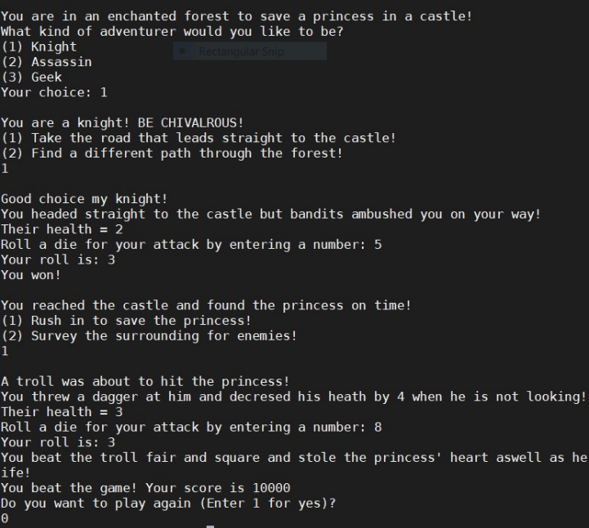 The program performed as intended I don’t find anything interesting because I programmed it and tested it out most of the cases… Maybe I was a little surprised that he was able to get past the 2 die rolls on the first attempt, with the chances of 5/6 on the first roll and 4/6 on the second making it 20/36 which is a 55.56% chance of passing.

* (up to 2 pts) Describe one improvement you would recommend to make your program better (more robust, more entertaining, more attractive, anything).

I would believe that my story line could be more interesting, and also, I could implement ascii pictures or video into my code for a more memorable user experience.

* (up to 2 pts) Modify your program to achieve one of these options, using a do/while loop:
  + Allow the user to play again if they want (at the end of the game, ask if they want to replay, and if so, start over).
  + Instead of quitting when the player enters an invalid choice, allow them to keep trying until they enter a valid choice. (You don’t have to do this for every choice but demonstrate it for at least one.)